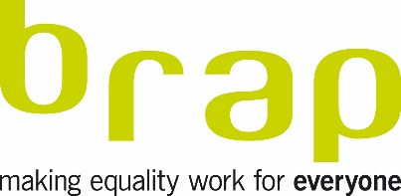
JOB DESCRIPTION
Job Title: Equality and Inclusion Facilitator

Salary band: £30k-37k per annum pro rata (full-time/part-time options available)

Job purpose
a) To devise, support and deliver a range of learning-based interventions which help individuals and organisations address inequality and discrimination
b) To lead, develop and deliver on projects, ensuring accountability to key stakeholders, including brap, and the relevant involvement and support of other team members

Duties and responsibilities
- Design and deliver a range of learning programmes
- Skilfully facilitate interventions using a range of approaches that are suited to the needs of learners (one-to-one, group based, seminar based and lecture based)
- Devise equality interventions, which are thoughtful and impactful
- Lead, plan and manage complex activities and projects, involving a range of stakeholders
- Build relationships that support the delivery of the organisation’s work
- Develop and market work in the pursuit of brap’s learning objectives
- Contribute to brap’s business planning cycle and associated organisational plans
- Lead on evaluative mechanisms that enable brap and others to understand the impact of our work

Person Specification

Essential
Knowledge
- A degree/appropriate expertise in a subject relevant to equality, inclusion, diversity, and human rights
- Ability to grasp complex data and apply it within relevant environments
- An understanding of change/improvement methodology
- Understanding of the experiences of vulnerable/marginalised people within our society

Learning
- An excellent understanding of how people learn
- Ability to employ different learning techniques and strategies
- Ability to facilitate both individual and group learning needs
- Ability to create rapport in different settings/different groups
- Willingness to learn and grow

Planning and organisation
- Excellent self-organisation skills and planning skills
- Ability to support and implement project planning processes
- Ability to liaise with funders and report on progress

Communication
- Excellent written and verbal communication skills
- Ability to think and operate at a strategic level
- Ability to motivate and support others
- Ability to advocate on behalf of the organisation and its objectives
- Excellent listening skills

Attitude
- Attention to detail and accuracy
- Works well in a vibrant and high-paced environment
- Proactive and confident
- Can maintain confidentiality
- Can work well under pressure and maintain deadlines
- Ability to be reflective
- Ability to work effectively across and within ‘different’ groups of people
- Ability to demonstrate empathy

Desirable
Research
- Ability to source data, which supports the delivery of accurate and relevant information.

Income generation
1. Ability to contribute to brap’s income generation activities as appropriate.

Line Manager: Facilitation & Learning Lead

